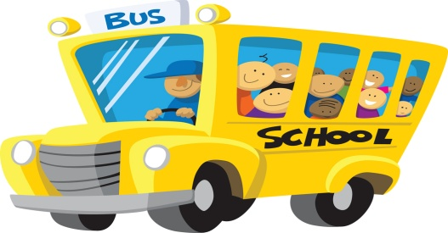
Kindergarten Curriculum

Math
Counts to 110 by 1’s
Counts to 30 by 5’s
Counts to 100 by 10’s
Counts to 30 by 2’s
Counts 30 objects
Reads and writes numbers up to 30
Locates numbers on a number line
Counts objects in sets
Compares and orders sets
Compare and orders numbers
Makes drawings for addition and subtraction stories
Writes addition and subtraction number stories
Understands numbers up to 30
Creates/describes/extends number patterns
Compares length, weight and capacity
Identifies tools to tell time (clock and calendar)
Uses words for parts of the day (morning, afternoon, night)
Tells time to the hour
Recognizes shapes (circle, square, triangle, rectangle, oval, rhombus, hexagon)
Sorts and classifies objects
Relates 3-D shapes to real life objects
(sphere, cube, cylinder, cone, rectangular prism)
Composes and decomposes numbers up to 10

Science
My Earth
Senses
Force and Motion
Living Things

Social Studies
Me
My Family
My School
My World
My Country

Writing
Writing Workshop
(writing daily in journals, conferences with the teacher and publishing pieces weekly)

Students will write genre pieces throughout the year
(personal narratives, informative pieces, opinion pieces, inquiry research piece)

Language Arts
Verbal Skills:
Listening and following simple directions
Speaking in simple sentences
Using appropriate language
Retelling an event
Expresses ideas orally

Reading and Language:
Recognizes and writes first and last name
Read and write 30 high frequency sight words
Recognizing upper and lowercase letters
Recognize 26 letter sounds including vowels
Understanding words that rhyme
Supplying words that rhyme (Give me a word that rhymes with cat…)
Understands the parts of a book (front, back, title, words, moving from left to right when reading)
Identify punctuation (period, comma, quotation marks, question mark and exclamation mark)
Understanding the blending and segmenting of words
Guided Reading

